(Approx. 227 words)

Online Music Radio Stations
By Len Nasman, Editor, Bristol Village Computer Club, OH
April-May 2018 issue, BVCC Newsletter
http://bvres.org/bvcchome.html
webmaster (at) bvres.org

If you have a computer connected to the Internet there are thousands of radio stations to choose from. Here are some examples.

Classical Music Stations
https://www.internet-radio.com/stations/classical/

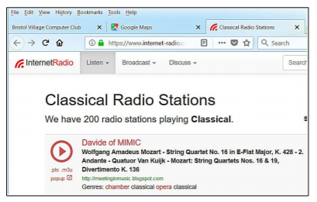
The scroll down list will change from time to time. Observe the Genres note for each listing. Just click on the play button to start the music. Once he music is playing, the play button becomes a pause button. You can keep the music playing while you open other program windows.

National Public Radio – NPR
https://www.npr.org/music/radio
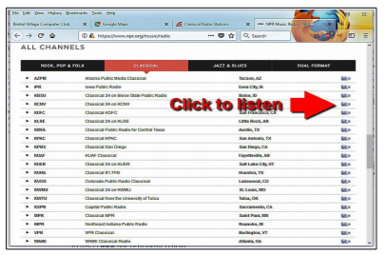
Once you have opened the NPR web site, scroll down to see a long list of local NPR stations. Observe that there is a menu bar that provides selections in different Genres. Click on the tool on the right side of the list to open the web page for that station.

Use VLC Media Player
The free VLC Media Player program can also be used to listen to radio stations around the world.
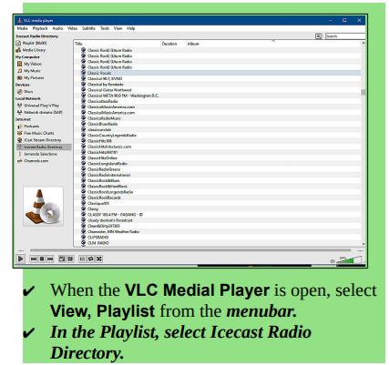
This opens a long list of radio stations around the world. You are on your own to experiment to see if you can find something interesting. After you open a radio broadcast, you can minimize VLC and keep it running in the background while doing other things on your computer.



